Tabla 1

|  |  |  |  |  |
| --- | --- | --- | --- | --- |
| C\AB | 00 | 01 | 10 | 11 |
| 0 | 1 | 1 | 1 | 0 |
| 1 | 0 | 0 | 1 | 1 |

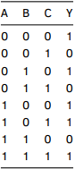 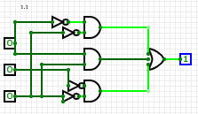

Y = A'C'+AC+B’C’

Tabla 2

|  |  |  |  |  |
| --- | --- | --- | --- | --- |
| C\AB | 00 | 01 | 10 | 11 |
| 0 | 1 | 0 | X | 0 |
| 1 | X | 0 | 1 | 0 |

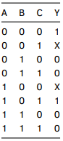 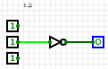

Y = B’

Tabla 3

|  |  |  |  |  |
| --- | --- | --- | --- | --- |
| CD\AB | 00 | 01 | 10 | 11 |
| 00 | 1 | 0 | 1 | 0 |
| 01 | 0 | 1 | 0 | 0 |
| 10 | 1 | 0 | 1 | 0 |
| 11 | 0 | 1 | 0 | 1 |

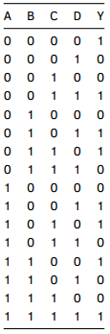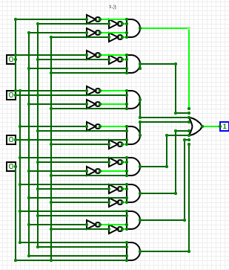

Y = A’B’C’D’+A’B’CD+A’BC’D+A’BCD’ + AB’C’D +AB’CD’+ABC’D’+ABCD

Tabla 4

|  |  |  |  |  |
| --- | --- | --- | --- | --- |
| CD\AB | 00 | 01 | 10 | 11 |
| 00 | X | 0 | 1 | 1 |
| 01 | X | X | 0 | 1 |
| 10 | X | 0 | X | X |
| 11 | 0 | X | 1 | 1 |

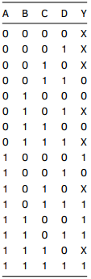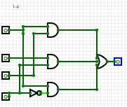

Y = AD’+AC+BD

Parte 2

1. Y = A · B · C · D’ + A ·( B · C · D)’ + (A + B + C + D)’

Y=AB’+BC’+B’C+D’

|  |  |  |  |  |
| --- | --- | --- | --- | --- |
| A | B | C | D | Y |
| 0 | 0 | 0 | 0 | 1 |
| 0 | 0 | 0 | 1 | 0 |
| 0 | 0 | 1 | 0 | 1 |
| 0 | 0 | 1 | 1 | 1 |
| 0 | 1 | 0 | 0 | 1 |
| 0 | 1 | 0 | 1 | 1 |
| 0 | 1 | 1 | 0 | 1 |
| 0 | 1 | 1 | 1 | 0 |
| 1 | 0 | 0 | 0 | 1 |
| 1 | 0 | 0 | 1 | 1 |
| 1 | 0 | 1 | 0 | 1 |
| 1 | 0 | 1 | 1 | 1 |
| 1 | 1 | 0 | 0 | 1 |
| 1 | 1 | 0 | 1 | 1 |
| 1 | 1 | 1 | 0 | 1 |
| 1 | 1 | 1 | 1 | 0 |

|  |  |  |  |  |
| --- | --- | --- | --- | --- |
| CD\AB | 00 | 01 | 10 | 11 |
| 00 | 1 | 1 | 1 | 1 |
| 01 | 0 | 1 | 1 | 1 |
| 10 | 1 | 1 | 1 | 1 |
| 11 | 1 | 0 | 1 | 0 |

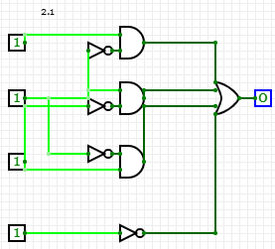

|  |  |  |  |  |
| --- | --- | --- | --- | --- |
| C\AB | 00 | 01 | 10 | 11 |
| 0 | 1 | 0 | 1 | 0 |
| 1 | 1 | 1 | 1 | 1 |

1. Y = A’ · B · C + (B · C’)’ + B · C

*Y=B’+C*

|  |  |  |  |
| --- | --- | --- | --- |
| A | B | C | Y |
| 0 | 0 | 0 | 1 |
| 0 | 0 | 1 | 1 |
| 0 | 1 | 0 | 0 |
| 0 | 1 | 1 | 1 |
| 1 | 0 | 0 | 1 |
| 1 | 0 | 1 | 1 |
| 1 | 1 | 0 | 0 |
| 1 | 1 | 1 | 1 |

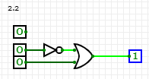

1. Y = (A + B + C)’ · D + A · D + B

Y=AD+B+C’D

|  |  |  |  |  |
| --- | --- | --- | --- | --- |
| A | B | C | D | Y |
| 0 | 0 | 0 | 0 | 0 |
| 0 | 0 | 0 | 1 | 1 |
| 0 | 0 | 1 | 0 | 0 |
| 0 | 0 | 1 | 1 | 0 |
| 0 | 1 | 0 | 0 | 1 |
| 0 | 1 | 0 | 1 | 1 |
| 0 | 1 | 1 | 0 | 1 |
| 0 | 1 | 1 | 1 | 1 |
| 1 | 0 | 0 | 0 | 0 |
| 1 | 0 | 0 | 1 | 1 |
| 1 | 0 | 1 | 0 | 0 |
| 1 | 0 | 1 | 1 | 1 |
| 1 | 1 | 0 | 0 | 1 |
| 1 | 1 | 0 | 1 | 1 |
| 1 | 1 | 1 | 0 | 1 |
| 1 | 1 | 1 | 1 | 1 |

|  |  |  |  |  |
| --- | --- | --- | --- | --- |
| CD\AB | 00 | 01 | 10 | 11 |
| 00 | 0 | 1 | 0 | 1 |
| 01 | 1 | 1 | 1 | 1 |
| 10 | 0 | 1 | 0 | 1 |
| 11 | 0 | 1 | 1 | 1 |

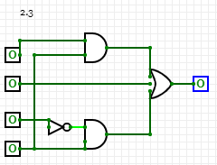

1. Y = B · C + A’ · B’ · C’ + B · C’

Y=B+A’C’

|  |  |  |  |
| --- | --- | --- | --- |
| A | B | C | Y |
| 0 | 0 | 0 | 1 |
| 0 | 0 | 1 | 0 |
| 0 | 1 | 0 | 1 |
| 0 | 1 | 1 | 1 |
| 1 | 0 | 0 | 0 |
| 1 | 0 | 1 | 0 |
| 1 | 1 | 0 | 1 |
| 1 | 1 | 1 | 1 |

|  |  |  |  |  |
| --- | --- | --- | --- | --- |
| C\AB | 00 | 01 | 10 | 11 |
| 0 | 1 | 1 | 0 | 1 |
| 1 | 0 | 1 | 0 | 1 |

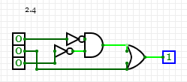

CODIGO GATES

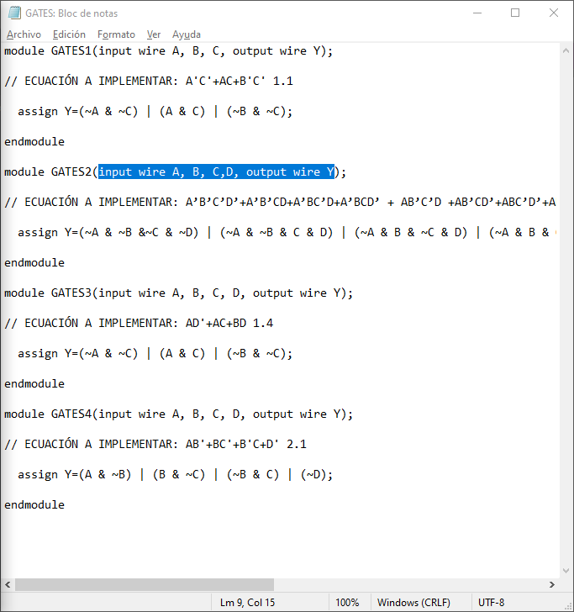

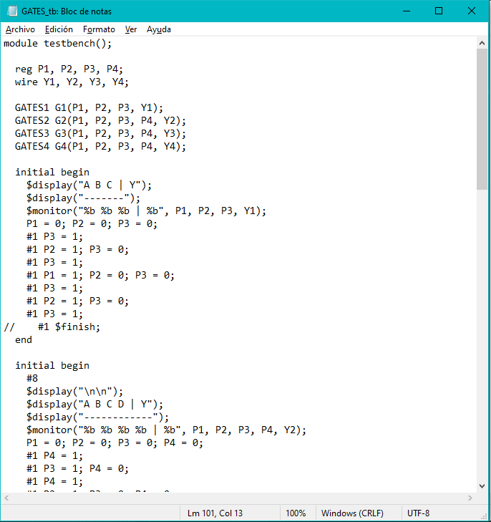 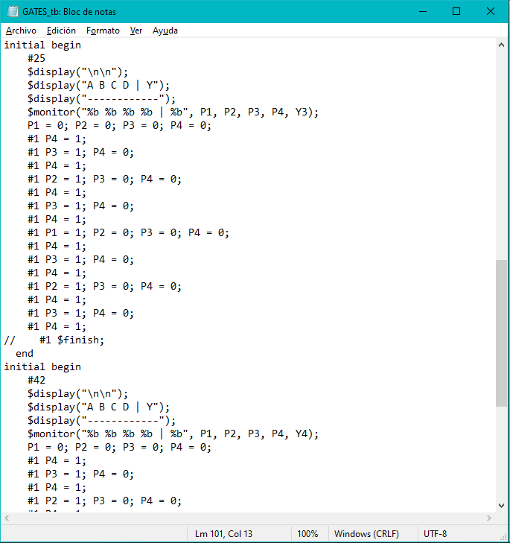

COGICO COMPUERTAS LOGICAS

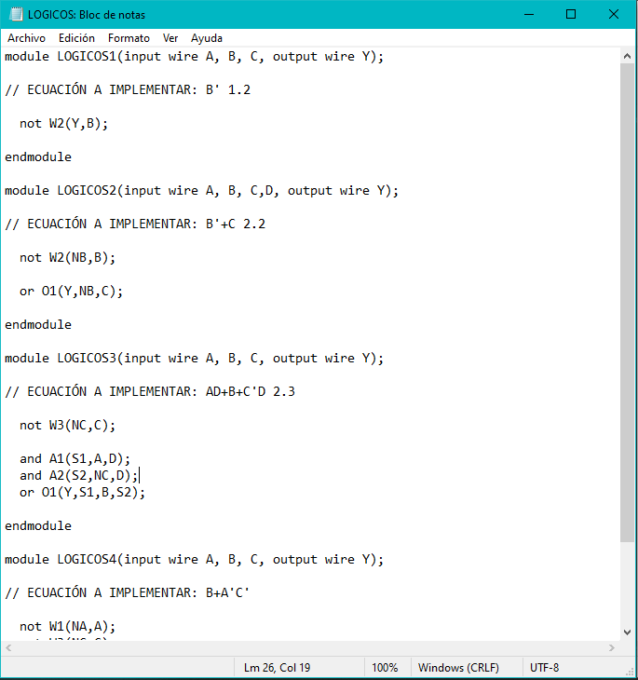 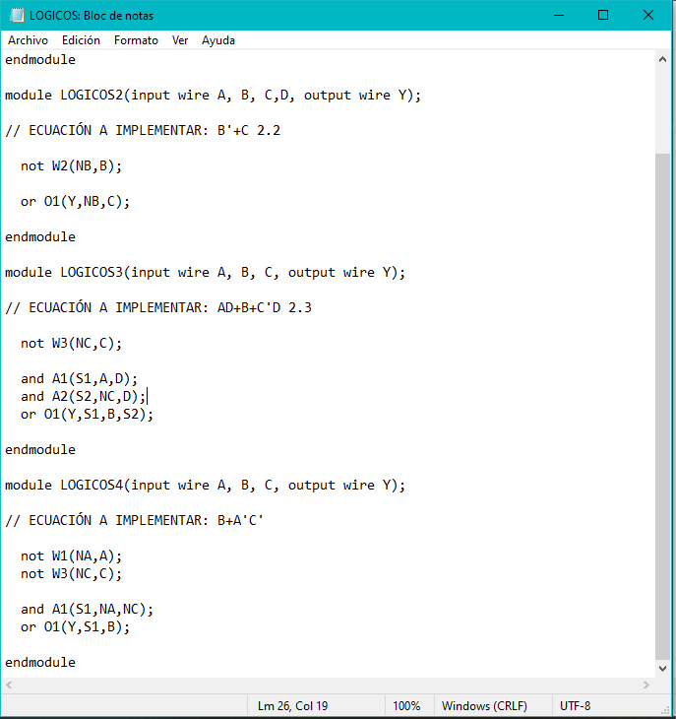 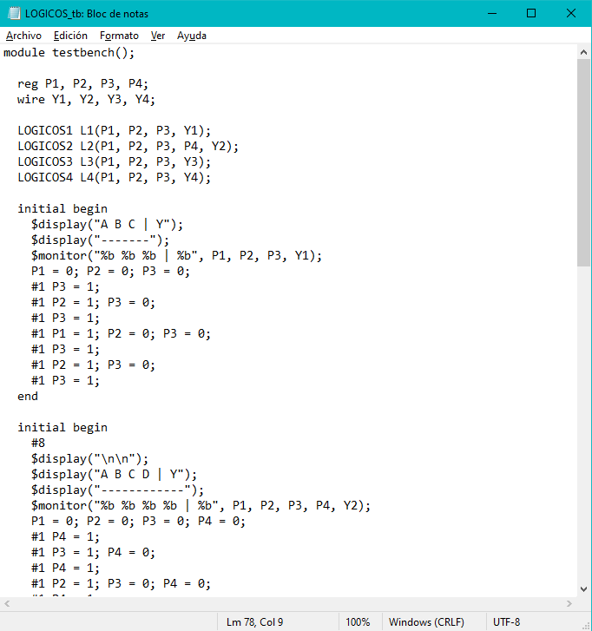 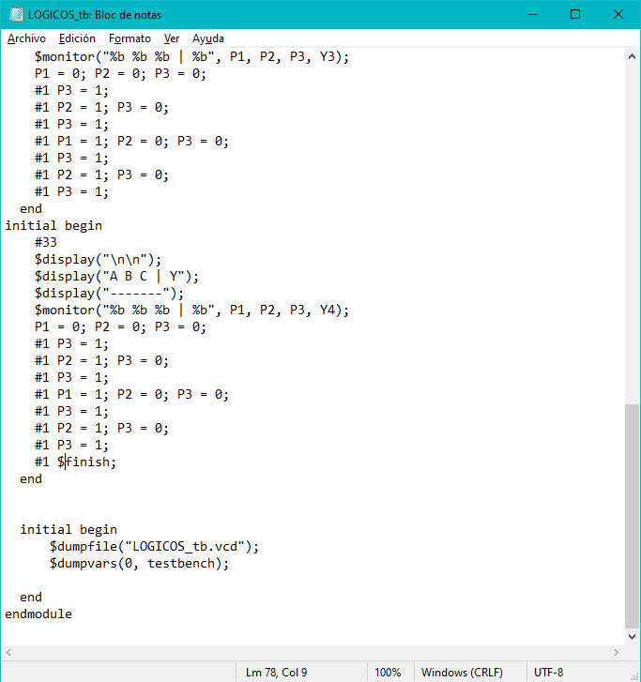

REPOSITORIO ONLINE

<https://github.com/dar17320/Lab-4>